Software Requirements Specifications (SRS)

ERP Solution for Lakhsma Sweater Ltd.

REFERENCE: GW/ERP/SRS/Accounts

Version: 1.0
Date of Release: October14, 2015


Genweb2 Limited
TK Bhaban (11th Floor),
13 Kazi Nazrul Islam Avenue,
Kawran Bazar, Dhaka 1215, Bangladesh
web: http://www.genweb2.com
Notice:

This document and any revised pages are subject to document control. Please keep them up-to-date using the release notice from the distributor of the document.

This is a hard copy of a document maintained on electronic media. It may not be the latest version. Ascertain the latest version from the Document Master List available with the Project Leader.

Authored by Mr. Asaduzzaman Date: 15-11-2015

Updated by .................................... Date: 15-11-2015

Revised by .................................... Date: 15-11-2015

Revised by ..................................... Date: 15-11-2015

Approved by _______________________________ Date:

Authorized by _______________________________ Date:

DOCUMENT RELEASE NOTICE

Notice Number : GW/ERP/SRS/Accounts/1/0

Client : Lakhsma

Project : ERP

Document Details : Software Requirement Specification for Accounts Management System

Name | Version No. | Description
Software Requirement Specification Document | 1.3 | Software Requirement Specification for Accounts Management System

Revision details:
Action taken  (add/del/chg) | Preceding  Page No. | New  Page No. | Revision  Description
 |  |  | Described in the Document Revision List

Change Register serial numbers covered:
- The documents or revised pages are subject to document control.
- Please keep them up-to-date using the release notices from the distributor of the document.
- These are confidential documents. Unauthorised access or copying is prohibited.

Approved by : Date:

Authorised by : Date:

DOCUMENT REVISION LIST

Notice Number :

Client : Lakhsma

Project : ERP

Document Name : Software Requirement Specification for Accounts Management System

Release Notice Reference (for release):

Rev.  No | Rev.  Date | Revision  Description | Page  No. | Prev.  Page  No | Action  Taken | Agenda /  New page | Release  Notice  Ref.
TABLE OF CONTENTS

1 INTRODUCTION 7
1.1 Purpose of SRS 7
1.2 SCOPE 7
1.3 DEFINITIONS, ACRONYMS AND ABBREVIATIONS 9
1.4 REFERENCES 9
1.5 OVERVIEW 9
2 GENERAL DESCRIPTION 10
2.1 PRODUCT PERSPECTIVE 10
2.2 PRODUCT FUNCTIONS 10
2.3 Actor in the Account module 10
2.4 USER CHARACTERISTICS 10
2.4.1 System Analyst 11
2.4.2 System and Database Administrator 11
2.4.3 Maintenance Team 11
2.4.4 End User 12
2.5 GENERAL CONSTRAINTS 12
2.6 ASSUMPTIONS AND DEPENDENCIES 12
3 Specific Requirements 13
3.1 Description of Functions Covered 13
3.1.1 Master set-up and Configuration 13
3.1.1.1 Currency Master 14
3.1.1.2 Period 15
3.1.1.2.1 Fiscal Year 15
3.1.1.2.2 Periods 15
3.1.1.3 Financial Year Master 15
3.1.2 Transactions 17
3.1.2.1 Vouchers 17
3.1.2.1.1 General Transaction 17
3.1.2.1.2 Reverse Voucher 17
3.1.2.1.3 General Voucher 17
3.1.2.1.4 Debit Advice Voucher 19
3.1.3 Bank Reconciliation 23
3.1.3.1 Bank Reconciliation 25
3.1.4 Day End Process 30
3.1.4.1 Day End Process 30
3.1.5 Annual Closing of accounts 32
3.1.5.1 Provisional Account Closing 32
3.1.5.2 Final Account Closing 34
3.1.5.3 Year End Voucher 35
3.1.5.4 Year End BDT Voucher 36
3.1.6 Reports 37
3.1.6.1 Cash Book 37
3.1.6.2 Bank Book 38
3.1.6.3 Journal Register 38
3.1.6.4 General Ledger 40
3.1.6.5 Sub-Ledger 41
3.1.6.6 Trial Balance 41
3.1.6.7 Income and Expenditure Statement 43
3.1.6.8 Balance Sheet 44
3.1.6.9 Monthly Statement: Banks 45
3.1.6.10 Salary Journal Register 45
3.1.6.11 Voucher Printing 47
3.1.6.12 List of Vouchers 49
3.1.6.13 Details of Sale 51
3.1.6.14 Details of Outstanding Amounts 51
3.1.6.15 Bank Statement 52
3.1.6.16 Bank Reconciliation 53
3.1.6.17 Daily Reconciliation Statement 54
3.1.6.18 Monthly Reconciliation Statement 55
3.1.6.19 Year End Journal Statement 56
3.1.6.20 Year End Trial Balance 57
3.1.6.21 Year End Income & Expenditure Statement 58
3.1.6.22 Year End Balance Sheet 58

INTRODUCTION

Purpose of SRS

The purpose of this document is to identify a set of requirements for an accounts module. The SRS helps us to describe the behaviour of the system to be developed. It includes a set of use cases that describe the interactions that the users will have with the software. Use cases helps to represent functional requirements of a system. In addition to use cases, the SRS also contains non functional (or supplementary) requirements.

This document is mainly directed to the Genweb2 and to the Lakhsma Blueprint team. The goal is to develop a common understanding of what the resource providers’ needs and expectations are and to understand how to design and develop the accounting system with the Lakhsma architecture.

The ultimate goal of the Central Accounts Module (CAM) is to strengthen the central accounts operational capacity by allowing an efficient recording, computation and retrieval of required accounting information by authorized users and managers and decision makers at any point of time.

This SRS is mainly intended for the user who deals with accounting processes.

SCOPE

The proposed Accounts module should provide the user organization with all the facilities that a complex, large and distributed accounts module needs. The system will provide a user friendly interface which would make it possible to run by an accountant with nominal computer literacy. All its interfaces would be quite self explanatory.

The whole software would be well organized and all its activities are designed in such a way that it is distributed across a good number of forms for the sake of simplicity. Some of the areas that will be covered are Budget, Voucher, Integration, Audit Trail etc. Most importantly, its backend algorithm and system design should make this “Accounts module” very secured and robust.

This Accounts module is based on accrual system and single entry system is out of scope. Income & Expenditure and Balance Sheet are designed for single column format.

Overall this detailed Software requirement specification will help the system analyst and developers get a clear view of the entire Accounts module requirements and its architecture.

The typical CAMS process includes the following phases:

- Master files
- General Accounting
- Bank Cheque Maintenance
- Staff Saving Scheme
- Foreign Currency Accounting
- Foreign Currency Revaluation
- Bank Reconciliation
- Regular Reports
- Account Statements
- MIS/Time Series Reports
- Linkage with other modules

DEFINITIONS, ACRONYMS AND ABBREVIATIONS

A list of abbreviations used in this document is given below:
SRS | Software Requirement Specification
CAM | Central Accounting Module

REFERENCES

This SRS has been prepared based on the preliminary study conducted by IT Division of Lakhsma, current computerized system and Discussion with the business owners.

OVERVIEW

This document is organised into two sections excluding this section.

Section 2 - General Description describes the functionality of the Central Accounts Management System. The details specified are:

Product Perspective

- CAM Product Functions
- CAM User Characteristics
- CAM General Constraints
- CAM Assumptions and Dependencies

Section 3 - Specific Requirements provides a detailed description of the functions of the CAMS in terms of:

- Inputs
- Processing
- Outputs

Section 4 – Interfaces with other modules are also described

GENERAL DESCRIPTION

PRODUCT PERSPECTIVE

The ultimate goal of the Central Accounts Module (CAM) is to strengthen the central accounts operational capacity by allowing an efficient recording, computation and retrieval of required accounting information by authorized users, managers and decision makers at any point of time.

This module will also have interfaces with other functional areas of Lakhsma such as Administrative Accounts Module, Inventory Module, Purchase Module, Merchandising Module, Commercial Module etc. The major functions under CAM module are as below:

PRODUCT FUNCTIONS

The different functions of the CAM module are:

- Master files
- General Accounting
- Cash Management
- Bank Cheque Maintenance
- Bank Reconciliation
- General Reports
- Linkage with other modules

Actor in the Account module

The following actors are identified for the account module:

- Head of Account
- Accounts Clerk / Assistant
- Assistant Accounts Officer

USER CHARACTERISTICS

The users of the CAM module can be categorized as:

- System Analyst
- System and Database Administrator
- End Users

System Analyst
- System Analyst is fully responsible to conduct periodical system requirements study and come up with proposal.
- Also responsible to conduct gap analysis, draw up SRS, Design and communicate the same to programmers.
- Testing and approval
- Conduct system auditing
- Planning periodical training for users

System and Database Administrator

The System and Database Administrator at Lakhsma production site is responsible for the proper functioning of the complete system. His / her responsibilities can be summarized as follows:

- System start-up and shut-down
- Providing operational assistance to end users
- Creating new user accounts and deleting defunct user details while monitoring system usage
- Allocating hardware and computer time
- Ensuring satisfactory performance of all hardware
- Periodic backing up of information to prevent data loss / corruption
- Maintaining the system data to ensure data integrity and security
- Establishing and applying data recovery norms
- Maintenance of master data
- Executing batch jobs, if any
- Executing batch report printing
- Implementing program enhancements at the production sites

Maintenance Team

DBA/Programmers at the Lakhsma IT Division will carry out all maintenance work. They are also responsible for the preparation of any ad-hoc queries / reports required for operational purposes after the system is implemented. For carrying out these activities, they should be conversant with the database design, three-tier configuration, and interface details.

The responsibilities of the analyst are as follows:

- Basic trouble shooting for software
- Ad-hoc report / query preparation
- Developing, testing, and documenting applications
- Consolidating data received from various units
- Assessing new requirements
- Maintaining the application software
- Data backup/Restore and security responsibilities
- Application and network error logbook maintenance

End User

The end users’ main responsibility will be transaction data entry and modifications. Also, their work will be initiation of batch processes and generation of reports. The end users’ jobs can be summarized as follows:

- Transaction data-entry
- Updating / Modification
- Report generation
- Maintain Application logbook

End users should be conversant with the functionality of the CAM Module.

GENERAL CONSTRAINTS

The following issues need to be resolved or decided upon:

Report formats need to be frozen before the completion of design

ASSUMPTIONS AND DEPENDENCIES

- All users are assumed to be equipped with GUI terminals.
- All master data entry will be undertaken jointly by LAKHSMA.
- All CAM users have undergone user training.
- Reports which are not freeze must be freeze before the completion of High level design.
- All the data requirement section given in all process will be given during the High level design stage
- Input parameters for report needs further discussion with the end users.

Specific Requirements

The details of the functionalities and major use case covered in the CAM module are:

- Master File Maintenance
- General Accounting
- Voucher Preparation
- Voucher Authorization
- Reverse Voucher Preparation
- Reverse Voucher Authorization
- Process Journal Report

- Bank Cheque Maintenance
- Record new cheque book
- Control Cancel Cheque

- Bank Reconciliation
- Bank Statements Entry
- Bank Statements Authorization
- Reconcile accounts

- Linkage with other modules

- General Reports

Description of Functions Covered

Given below are functions along with their descriptions.

Master set-up and Configuration
This function maintains setup/configuration master used by this module. This is the first function that users must carry out during the initial setup of this module at proposed installation site. The generic setup parameters are likely to be organisation name, address, financial year, number format, currency format, number of decimal places, voucher initial values etc.

Following are the masters from:

- Currency Master
- Periods
  - Fiscal Year
  - Periods
- Journal Type
- Accounts
  - Accounts Type
  - Chart of Accounts
  - Bank Accounts

Currency Master

Description
This function maintains details of various currencies. The currency master links two GL Codes with every Currency for the GL Codes that will be affected on the ledger/final accounts for mixed currency transactions. Note that bullion (gold and silver) will also be treated as currency as their nature in transaction is same as other currencies. The only difference is that apart from the value these will have a stock also (not maintained through this screen). For every currency the details of their applicable denominations will be maintained in the detail section.

Screen Layout
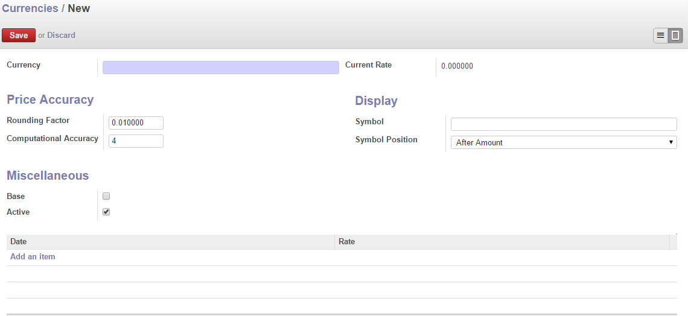
Fig: Currency Create

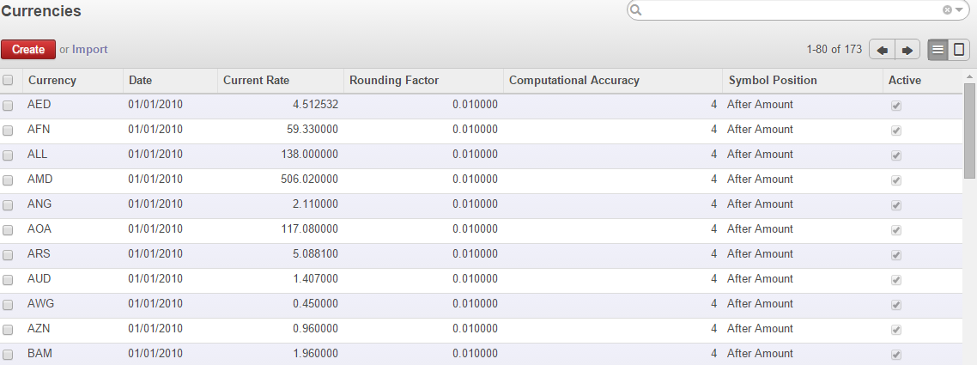
Fig: Currency List

Period
Description
This function maintains the details.....

Fiscal Year

Screen Layout

Periods

Financial Year Master
Description
This function stores the different financial years of the system. This and other modules as well as report generation require this information.

Actors or Participants
User of Banking Division

Pre Conditions
N/A

Screen Layout
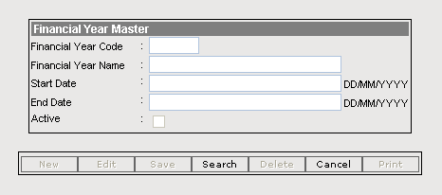

Inputs
The contents of Financial Year Master are:
Financial Year Code* | Code of the financial year
Financial Year Name* | Descriptive Name of the financial Year
Start Date* | Start date of the financial year
End Date* | End date of the financial year
Active | Whether the financial year is active

Data Store
Financial Year Master Data store
The following inputs will be stored in the Financial Year Master data store:
    - Financial Year Code
    - Financial Year Name
    - Start Date
    - End Date
    - Active

Business Logic
- Code and name has to be unique.
- Only one financial year may be active at a time.

Process
Enter and update Financial Year Master data store.

Example:
Financial Year Code | 0405 | 0506 | 0607
Financial Year Name | Year 2004-2005 | Year 2005-2006 | Year 2006-2007
Start Date | 01/06/2004 | 01/06/2005 | 01/06/2006
End Date | 31/05/2005 | 31/05/2006 | 31/05/2007
Active | N | Y | N

Verification and Validation
NA

Analytical / Calculation
NA

Transactions

Vouchers

General Transaction
This functionality will maintain the normal Ngultrum vouchers maintained by Banking Division. The process and business logic is same as with the general transaction of AAM module. Refer the following Use Cases of AAM module

- General Transaction (Section 3.1.2.2.1 of Document ICBS/AAM/STDSRS/SRS-AAM-003)

Reverse Voucher
Refer the following Use Cases of AAM module
CAM will use the same reversal voucher interface used by the AAM to reverse the authorised voucher.
- Reverse Journal (Section 3.1.2.2.2.1 of Document ICBS/AAM/STDSRS/SRS-AAM-003)

General Voucher

Description
This function will manage the normal currency voucher where the currency used is same for all the account heads. This function is similar to the General Transaction (Nu) with foreign currency involved.

Actors or participants
Banking Division Users

Screen Layout
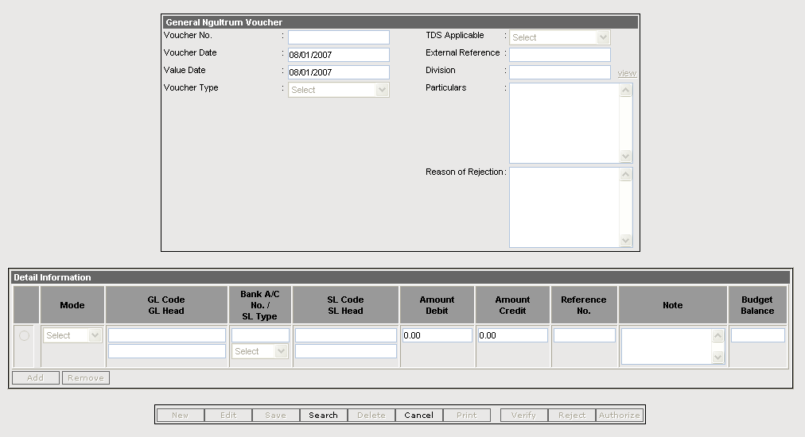

Inputs
The contents of General Ngultrum Voucher data store are:
Voucher No* | System generated unique no of voucher.
Voucher Date | System date
Value Date* | The date that this Transaction takes effect.
Voucher Type* | The unique ID number of the transaction type in which this Transaction would be documented.
TDS Applicable | Tax Deduction at Source [User will select form a list]
External Reference | Physical Document no for this Transaction
Division | The Division to which this entry is relevant.
Particulars* | A plain text description of this Transaction
Reason of Rejection | Remarks for rejection

Corresponding to the entry above the following attributes will be entered in detail.
Mode * | There will be master for Bank Reference type which are basically Cheque, Pay Order, Draft etc.
GL Code* | Unique Code for GL
GL Head* | The unique ID number of the General Ledger Head to be debited or credited.
Bank A/C No /SL Type | The unique ID number of the Sub-Ledger Head to be debited or credited or Bank A/C No.
SL Code | Unique Code for GL
SL Head | SL Description
Amount Dr* | The amount to be debited.
Amount Cr* | The amount to be credited
Ref No. | Existing no of Bank Reference (Cheque no/Draft No.). System will automatically put the available unused cheque number against the bank account
Note | An alphanumeric text description for this entry.
Budget Balance | Budget Balance

Data Store
The above mentioned inputs will be stored in the following data stores:
- General BDT Voucher Header
- General BDT Voucher Detail

Post conditions
NA

Flow of Events
- Authorised user will prepare the voucher by entering the details as described in the data stores
- Once voucher is prepared user will print it and sign on as “Prepared By” and submit for verification and authorisation
- Once voucher is verified it will be ready for authorisation
- Once authorised, voucher will be locked and balances will be updated

Business Logic
- Each Transaction has to be marked by a voucher type
- Voucher Number will be system generated, voucher number will be reinitialised every year
- There can be one debit-many credit, one credit-many debit and one debit-one credit
- Users will be able to both select and enter a/c code or description
- While searching for an account filtering facility will be made available
- The current unused cheque number against the selected bank account will come automatically
- Cheque number will be cancelled automatically when the voucher using the cheque number is reversed

Verification and Validation
- Voucher type, Date, Number, amount, particular/narration, currency code can not be null
- User can’t put both debit and credit amount for a GL/SL entry
- If for a GL/SL entry the debit and credit amount is 0 then it will be discarded
- All Mandatory fields are marked by “*”.

Analytical / Calculation
NA

Application Error
NA

Debit Advice Voucher

Description
This function will manage the BK01/Debit Advice Voucher BK01 voucher is used in following transactions
- Foreign Currency Payment/Release
- Sale of Bullions

Actors or participants
Banking Division Users

Screen Layout
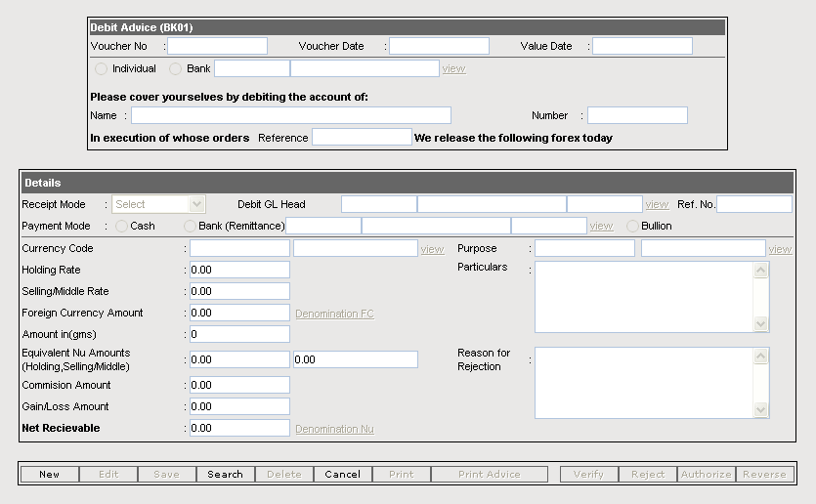

Inputs
The contents of BK01 data store are:
Voucher No. | Voucher Number
Voucher Date | Voucher Date
Value Date | Effective Date [By Default System Date but user can edit it]
Individual/Bank | User will select between this two option[Individual/Bank/Bullion]
Name | Name of the person
Number | Unique Number of voucher
Reference

Corresponding to the entry above the following attributes will be entered in FC Voucher detail.

Receipt Mode | Mode of Receipt [user will select form list]
Debit GL Head | Debited Bank Name[User will select form a list]
Reference Number | Reference Number
Payment Mode | Mode of Payment[Cash/Bank]
Currency | Currency [User will select form a view link]
Holding Rate | Holding Rate[User entered]
Selling/Middle Rate | Selling /Middle Rate[user entered]
Foreign Currency Amount | Amount of Foreign Currency[user entered]
Amount in (gms) | Amount in Grams[User entered]
Equivalent Nu Amount(s) | Equivalent NU Amount
Commission Amount | Commission Amount[System Generated but user can edit ]
Gain/Loss | Gain/Lose Amount[calculated by system]
Net Receivable | Total Amount
Purpose | Purpose of transaction[User will select form a list]
Particular | Particulars of transaction
Reason for Rejection | Remarks for rejection

Data Store
The above mentioned inputs will be stored in the following data stores:
- BK01 Data store
- General FC Voucher Header
- General FC Voucher Detail
- General Nu Voucher Header
- General Nu Voucher Detail

Output
Population of BK01 Data store, General FC Voucher Header, General FC Voucher Detail, General Nu Voucher Header, General Nu Voucher Detail data store, printing of vouchers

Post conditions
- None

Flow of Events
Foreign Currency Payments and Release
- Forex division will issue a authorization letter to the banking division for Foreign payment/releases
- Upon receipt of the authorization letter from the Forex Division the banking division will check the date, currency code, amount, beneficiary account and other details
- Swift Message is prepared and send to swift operator
- On the basis of the above information system will generate following:
- Total of TCs/Notes
- Commission Amount Calculated from Selling rate and holding rate
- Equivalent in BDT = Total of TCs & Notes * Hold Rate
- Total = Total of TCs & Notes * TT Sell Rate
- Commission Amount = Total – Equivalent in Nu
- Prepare the voucher and print and sign on ‘Prepared By’
- Go thru the normal verification and authorization process
- Once voucher is prepared any modification on the Forex authorization letter has to be manually effected on voucher
- Once it is approved any modification on the Forex authorization cannot be implemented. In that case the current voucher has to be reversed and a new voucher has to be prepared
- The nature of accounting for this voucher is given as bellow:

Ngultrum Accounting
Debit Bank/Cash
Credit VOC (Cy)
If Income from Exchange/Commission
Credit Commission Income
If Expense for Exchange/Commission
Debit Commission Expense

FC Accounting
Debit Our Cy (Cy)
Credit TC Account or Cash In Hand (CY)
Bullion Bar Sale
The BK01 voucher is also used for selling of Bullion bars at Lakhsma. Selling of bullion bar requires management instruction
The steps for selling bullion bar are as follows:
      - Upon receipt of the instruction from the Management the banking division will check the date, Bullion Type, amount, beneficiary account and other details
      - On the basis of the above information system will generate following:
  - Exchange gain/loss Calculated from Selling rate and holding rate
  - Equivalent in BDT = (Total of Bullions) * Hold Rate
  - Bank Total = Gain/(-Loss) in BDT + Total of Bullions * Sell Rate
      - Prepare the voucher and print and sign on ‘Prepared By’
      - Go thru the normal verification and authorization process
      - The Issue division will access the voucher from their system and will prepare their voucher motif wise
      - The information which are common to BK01 and issue division voucher will automatically reflected when they prepare their voucher
      - The nature of accounting for this voucher is given as bellow:

Ngultrum Accounting
Debit Foreign Exchange Current Ac
Credit VOC (Gold or Silver)
Credit Income from other sources

Bullion accounting in grams
Debit Our Gold/Silver Bar
Credit Gold/Silver Bar

Business Logic
- For each entry to BK01 data store there will be corresponding entry in Nu Voucher data store and FC voucher data store
- Verification and authorisation information will be copied from BK01 voucher data store to Nu and FC voucher data store
- If Cash is selected system will automatically debit the cash related GL head
- If Bank is Selected ,System will allow to enter/select Bank related GL head
- Gain/loss is calculated from(Holding Rate*Exchange Amount)-(Selling rate*Exchange Amount)
- If (Holding Rate*Exchange Amount) > (Selling Rate* Exchange Amount) then the difference is consider as a lose and Vice- versa
- Commission is required for some high level remittances decided by the management, and calculated at 1% of the total NU amount.
- Commission Charges: 1% of the total amount between 500 to 10000 is charge as commission.
- If 1 % of commission comes above Nu 10000 then the commission is limited to Nu 10000 only
- Calculated Commission is appropriately rounding off

Verification and Validation
- Account head debited and credited has to be validated from account mapping data store
- All Mandatory fields are marked by “*”.

Analytical / Calculation
- Commission Amount= (Total of TCs & Notes) * Holding Rate - (Total of TCs & Notes) * selling Rate
- BDT Equivalent = (Total of TCs & Notes) * Holding Rate
- Bank Total = Commission in BDT + Total of TCs & Notes * TT Sell Rate

Application Error
NA

Bank Reconciliation

In order to keep up to date track of all receipts and payments of funds as well as to monitor and reconcile the balance in the account, it is necessary to carry out reconciliation exercise daily, weekly or monthly as require by the users. In order to facilitate easy and immediate reconciliation of transactions between Lakhsma and its correspondent banks and to prevent any reconciliation complications, every transaction has to be responded singly by Lakhsma as well by its correspondent banks.

For ease of reconciliation, both the Lakhsma and the banks shall always try to reflect the transaction individually and there should not be more than one entry from the Lakhsma side corresponding to single entry from bank side and vice-versa.
The whole purpose of the exercise is to keep track of all the outstanding transactions i.e. not responded either by the banks or the Lakhsma.
Common steps for the Bank Reconciliation Process are:
Bank Statement Entry
Prior to reconciliation process, it is necessary to input bank statement which is required to compare against the Lakhsma ledgers.

Process: This process will carry out the following steps:

- On receipt of bank statements from the correspondent banks, the concerned user shall verify the transactions listed therein and input the following information into the system, bank account wise on header/parent part of the form as below:

- Reconciliation Record ID (System generated)
- Net balance of the bank statement account wise.
- Specify DR or CR
- Lakhsma Ledger balance (System generated)
- Account Number
- Transaction/record date
- Bank Statement Date

- The details of the bank statement shall be entered in the child/details part of the form as below:
- Debit amount
- Credit Amount
- Reconciliation reference number (Check No/Clearing Number/Advice No etc)
- Match Date (This date field will be null if not reconciled. Reconciled Date will be written whenever reconciled by the system and therefore this field is not visible to user).
- Transaction date of each statement records.
- Once the statement is entered into the system, a copy of bank statement as a proof sheet shall be printed.
- User responsible for preparation shall verify it and sign on the “Prepared by:” column and forward to Verifying Officer along with the original bank statement received from bank.

Verify/Approve Bank Statement

Process: This process is required to verify and approve the Bank Statement entered into the system prior to beginning of conciliation process. The steps involved are as below:

- Upon receipts of the proof sheet along with the original bank statement from the concerned user, the Approving/Verifying Officer shall input the unique bank statement reference number assigned by the system to the proof sheet.
- Once the required record is searched and displayed on the screen, the Verifying/Approving Officer shall approve or reject depending on the correctness of the entry.
- Following the approval of the proof sheet by singing on the “Approved/Verified by:” column, it is also necessary to complete online approval process.
- The proof sheet and the necessary documents shall be properly signed and passed back to the user responsible to reconcile the accounts.

Automatic Reconciliation

Process: This process shall carry out the following steps:

- Prior to reconciliation process all bank related transactions are accumulated into a separate working table during data entry phase.

- Once the statement is key-in, the system shall perform following matching of the bank statement records with that of corresponding bank records being maintained in the Lakhsma ledgers.
- Matching of amounts
- Matching of cheque/advice/ instruction numbers
- Debit verses credit matching
- Any transactions, which do not agree to the above criteria, are left un-reconcile. The matching transactions are flagged as reconciled by recording the matching date and/or flagging both accounts date and the reconciliation records.
- The unmatched transactions shall be displayed on screen and/or printed to printer to allow user verify again. Sometimes the matching is failed due to merging of more than one transactions into single transaction, mistakes in data entry and/ or inconsistency in assigning references in case of draft, charges and transfer etc.
- User shall print both the lists (Annex I and Annex II) for not reconciled entries and make necessary correction.
- Should there be any mistake due to data entry, or mistakes in bank statement such mistakes shall be first corrected on the paper lists and then updated accordingly in the respective tables using appropriate form/interface.
- Once the corrections are made into the system, reconciliation process shall be re-run once again.

Manual Reconciliation

Process: Any records failing to reconcile automatically due to non-availability of one-to-one matching reference number, shall be matched manually as below:

- User shall input bank statement entry date, bank account number and/or proof sheet reference number into the system. Accordingly, system shall search for the matching record (un-reconcile records) and display on manual reconciliation screen.

- Using such screen user shall match the records manually on screen. However, user must be extra careful and match only those records which system failed to match automatically due to non-availability of one one-to-one matching reference number.

- Once the reconciliation process is completed it is ready to generate following reports:
- Daily Reconciliation Register
- Daily Reconciliation Statement
- Monthly Reconciliation Summary
- Annex – I (List of transaction not responded by the Bank)
- Annex – II (List of transaction not responded by the Lakhsma)

Bank Reconciliation
Description

This function will enable user to enter the bank statements for different bank accounts where foreign currency is involved and then reconcile the bank transactions. This function is similar to the Nu reconciliation process. Only difference is, here foreign currency is involved

Actors or participants

Banking division users

Screen Layout

Bank Statement:

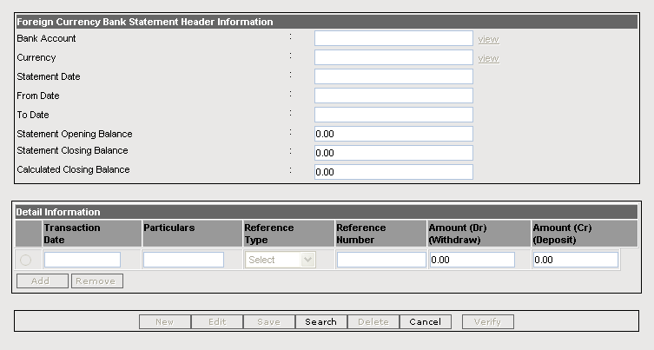

Bank Reconciliation:

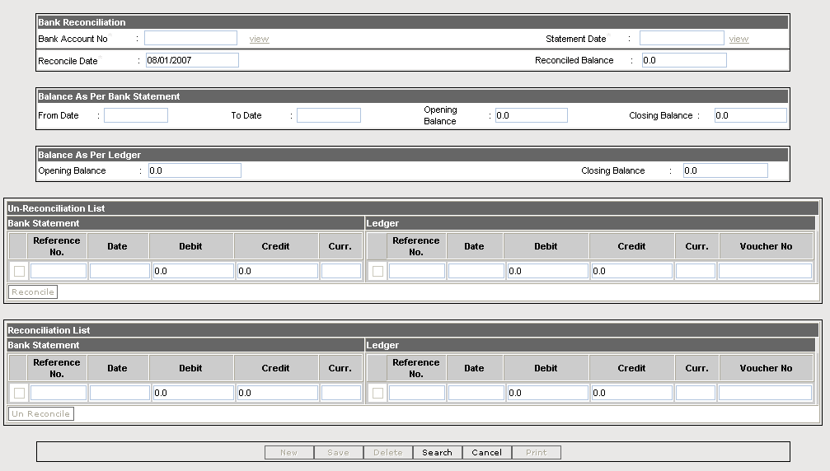

Inputs
The following are inputs into the FC Bank Transaction when any bank transaction has been posted

Date* | Date of the payment or receipt entry of General Ledger
Ref Date* | A date of Cheque/Draft that identifies the date of bank reconciliation.
Foreign Currency Code* | Foreign currency involved in this transaction
Reconciled | [Y/N] if reconciled or not
Bank Statement* | Bank statement against which it has been reconciled
Reconciled Statement | Reference to the reconciliation statement
Transaction Mode* | This attribute identifies the Bank Reference Type for which this bank transaction is relevant.
Bank Account* | Bank Account which identifies the Bank Account No.
Amount Dr* | The amount that indicates the debit amount of the bank entry.
Amount Cr* | The amount which indicates the credit amount of the bank entry

The following are inputs into the Bank Statement Header
Bank Account* | Bank Account which identifies the Bank Account No.
Statement Date | Bank statement Date
Statement Opening Balance | Opening balance as recorded in the Bank Statement
Statement Closing Balance | Closing balance as recorded in the Bank Statement

Corresponding to the Bank Statement Header following are inputs into the Bank Statement Detail

Ref No | The Cheque No/Draft No in the system
Ref Date* | A date of Cheque/Draft
Transaction Mode | This attribute identifies the Bank Reference Type for which this bank transaction is relevant.
Date* | Transaction date in bank statement
Reconciled | [Y/N] if reconciled or not
Amount Dr* | The amount that indicates the debit amount of the bank entry.
Amount Cr* | The amount which indicates the credit amount of the bank entry
Currency Code* | Code for the foreign currency involved
Note | An alphanumeric text description for this entry.

Input to the Reconciliation statement
Reconciliation Date* | The date on which the statement has been prepared
Reconciled Balance* | Balance after reconciliation

Data Store
Foreign Currency Transaction Data Store
The following inputs will be stored in Foreign Currency Transaction data store:
    - Date
    - Ref Date
    - Foreign Currency Code
    - Reconciled
    - Bank Statement
    - Reconciled Statement
    - Bank Account
    - Amount Dr
    - Amount Cr

The following inputs will be stored in Bank Statement Header data store
    - Bank Account
    - Statement Date
    - Statement Opening Balance
    - Statement Closing Balance

The following inputs will be stored in Bank Statement Detail data store
    - Ref No
    - Ref Date
    - Transaction Mode
    - Date
    - Reconciled
    - Amount Dr
    - Amount Cr
    - Currency Code
    - Note

The following inputs will be stored in Reconciliation statement data store
    - Reconciliation Date
    - Reconciled Balance

Output

Populating FC Bank Statement Header, FC Bank Statement Detail, FC Updating Bank Entry

Flow of Events
- As described above (Section 3.1.3)

Business Logic
- The system will reconcile the transaction by matching the cheque number (DocID) of Bank entries and transaction from Bank Statements. Additionally there can be option for matching the entries by cheque date, reference number and debit, credit amount
- Transactions which are not reconciled by above process will be reconciled by the user from the user interface
- When a Bank Entry is reconciled against a bank statement its reconciled flag will be true and the corresponding BankStatementID of Bank Statement will update BankStatementID field. Also the reconciled statement id will be updated by the corresponding reconciled statement id from the reconciled statement data store

Verification and Validation
- All Mandatory fields are marked by “*”.

Analytical / Calculation
- None

Application Error / Messages
Validation document mentioned at references (1.4)

Day End Process
Day End Process is to control the day ending scenario. After the day is ‘ended’, that is locked, no more vouchers are to be posted from either AAM or CAM.

Day End Process
Description
This function can be used to lock and unlock a day so that posting of vouchers from AAM and CAM may be controlled. In order to ‘end’ and lock a day, it is necessary that the user matches withy the physical balances and check all matched values.

Purpose
This function can be used to lock and unlock a day so that posting of vouchers from AAM and CAM may be controlled.

Screen Layout
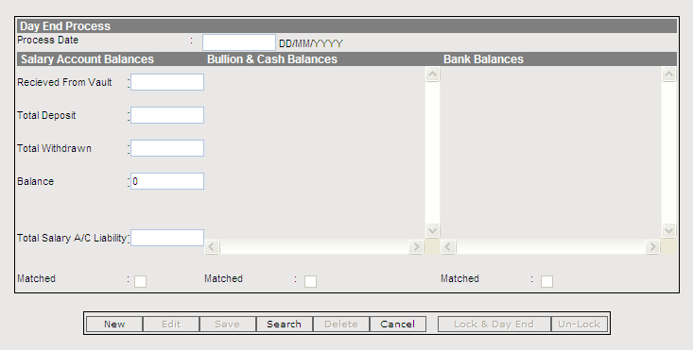

Inputs
Received from vault | The amount that is received from vault for staff salary cash a/c
Salary Account Balances Matched | Whether Salary account balances are matched
Bullion & Cash Balances Matched | Whether Bullion and Cash balances are matched.
Bank Balances Matched | Whether Bank Balances are matched

Data Store
Day End Data store
The following inputs will be stored in Withdrawal Data Store:
    - Process Date
    - Received from Vault
    - Salary Account Balances Matched
    - Bullion & Cash Balances Matched
    - Bank Balances Matched

Flow of Events
  - At Day Beginning, the amount received from the vault for the Staff Salary Cash Account will be entered.
  - At Day End, the Banking Division will match the individual system provided balances and match them with the physical balances.
  - Then they will Lock the day for no further vouchers.
  - A day may be unlocked again to post further vouchers, if the need arises.

Business Logic
- The Day Cannot be ‘Locked’ if all the balances are marked as matched.
- The day may be unlocked at any time by authorized users.

Verification and Validation
NA

Analytical / Calculation
NA

Application Error
NA

Annual Closing of accounts

Annual Account closing is common for both Administrative Division and Banking Division.

The annual closing of accounts will be done in two phases -
- Provisional Account Closing
- Actual Account Closing

Provisional Account Closing

Description
This process will not actually close the account but will calculate the provisional balance sheet, income & expenditure statement and other related financial statements; and will carry forward to the next financial. However, final financial statements will be completed upon external auditing process.

Purpose
In order to run the system in the new financial year without actually closing the accounts and posting the year ending journals, this process will calculate the provisional balance and carry forward to the new financial year

Screen Layout
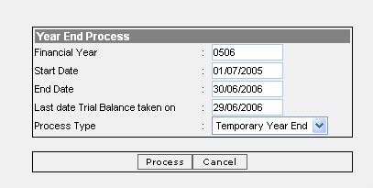

Inputs
The following are inputs into the GL Balance data store

Financial Year* | Financial Year for which year ending is being done
Month Code* | Number specifying the month ex: 01 for January, 02 for February
GL Code/SL Code* | GL account Code
Closing Balance* | Closing Balance for that month

Following are the inputs to financial year data store
Financial Year* | Financial Year for which year ending is being done
Start Month Code* | Financial Year Start Month
End Month Code* | Financial Year End Month
Year End Flag* | Y/N whether year has been closed or not

Data store
General Transaction, General FC transaction, GL Balance, Financial Year Data Store

Process Description: The process will have the following steps:
- Calculate the balances of Assets and Liabilities accounts and carried forward to new financial year as probationary balances.

- Unlike the existing system, the adjustment vouchers for June month can be entered into the system at anytime instead of accumulating into batches.
- Update the probationary balances as and when adjustments vouchers are booked for the June.
- Process all report required before closing of accounts
- The system should generate a provisional report

Post conditions
Preparing various financial report

Special requirements
Security
- Only authorize user who will be given rights to access this function will be able to do the year ending process

Business rules
- Calculate the provisional profit and loss amount from income and expenditure transactions
- Add the amount to the closing balance of Profit and Loss account for the year ending month
- Make the balance 0 for income and expense heads for the year ending month
- Create a new financial year and update the current financial year as closed
- Update the closing balance for Asset and liabilities for the year ending month

Verification and Validation
NA

Analytical / Calculation
NA

Application Error
NA

Final Account Closing
Description
This process will pass a year ending journal

Purpose
To close a financial year

Pre Conditions
- All the adjustment entries has been passed
- All the provision vouchers has been passed
- Auditors has finalised and board has approved the financial statements

Screen Layout

Inputs
The following are inputs into the GL Balance data store
Financial Year* | Financial Year for which year ending is being done
GL Code* | GL account Code
Closing Balance* | Closing Balance for that financial year
Currency | Currency of closing balance

Data store
General Transaction, GL Balance, Financial Year Data Store

Output
Populating GL Balance

Post conditions
NA

Process
Final adjustment vouchers are entered into the system, and the accounts for the current financial year are closed.

Special requirements
Security

- Only authorize user who will be given rights to access this function will be able to do the year ending process

Business rules
- Create a journal voucher by reversing the income /expenses transaction (if Debit then credit and vice versa) and posting the balance amount (Total Income- Total Expenses) to the Profit & Loss account
- Update the Balance of all asset and liabilities for the year ending and accordingly update the balances up to the current month
- Make the balance 0 for income and expense heads for the year ending month

Verification and Validation
NA

Analytical / Calculation
NA

Application Error
NA

Year End Voucher
This functionality will maintain the normal Ngultrum vouchers maintained by Administrative Division, with a difference that they can change the Voucher Date (which is by default display field). The process and business logic is same as with the general transaction of AAM module. Refer the following Use Cases of AAM module

- General Transaction (Section 3.1.2.2.1 of Document ICBS/AAM/STDSRS/SRS-AAM-003)

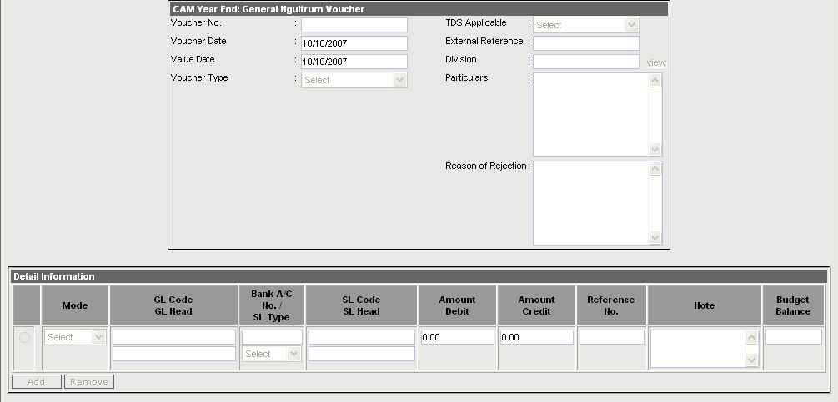

Year End BDT Voucher
This functionality will maintain the normal Ngultrum vouchers maintained by Banking Division, with a difference that they can change the Voucher Date (which is by default display field). The process and business logic is same as with the general transaction of CAM module. Refer the following Use Cases of CAM module

- General Transaction (Section 3.1.2.2.1 of Document ICBS/CAM/STDSRS/SRS-CAM-003)

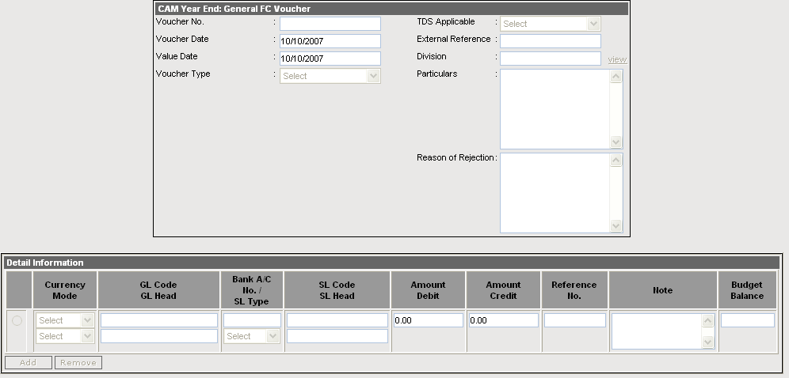

Reports

Cash Book

Description
This process is to generate the Cash Book

Purpose
The purpose of this report is to the check and verifies the listing of transaction for a day or period

Input Parameters
- From Date
- To Date
- GL Code (Must be Cash Related)

Data Elements
This report will contain the following data elements.
Elements | Description
Account No | Account Code from Transaction Detail
Account Name | Account Head from Chart of Account for the Account Code
Voucher Number | Voucher Number
Value Date | Date of the line transaction
Particulars | Line details for the transaction
Debit Amount | Amount debited on the GL/SL head
Credit Amount | Amount credited on the GL/SL head
Balance | Cash Balance

- At the end of the day the Accounts department can print the Cash Book and tally with the physical cash balances.

Report Layout

Lakhsma Sweater Ltd
Cash Book
For the period of 01/04/2006 – 02/04/2006
Account No.: 1201001
Account Head: Cash in Hand

Value Date | Voucher No. | Particulars | Amount Debit | Amount Credit | Balance
 |  | Opening Balance |  |  | 15000.00 DR
01/04/2006 | AAM\PV\0607\1 | Pay to J D Enterprise |  | 5000.00 | 10000.00 DR
02/04/2006 | AAM\RV\0607\2 | Received from Digital Shangrila as an Earnest Money Deposit | 25000.00 |  | 35000.00 DR

Bank Book

Description
This process is to generate the Bank Book

Purpose
The purpose of this report is to the check and verifies the listing of transaction for a day or period

Input Parameters
- From Date
- To Date
- GL Code (Must be Bank Related)

Data Elements
This report will contain the following data elements.
Elements | Description
Account No | Account Code from Transaction Detail
Account Name | Account Head from Chart of Account for the Account Code
Voucher Number | Voucher Number
Value Date | Date of the line transaction
Particulars | Line details for the transaction
Debit Amount | Amount debited on the GL/SL head
Credit Amount | Amount credited on the GL/SL head
Balance | Bank Balance

- At the end of the day the Accounts department can print the Bank Book and tally with the physical bank statements.

Report Layout

Lakhsma Sweater Ltd
Bank Book
For the period of 01/04/2006 – 02/04/2006
Account No.: 1201001
Account Head: BNB Current A/c

Value Date | Voucher No. | Particulars | Amount Debit | Amount Credit | Balance
 |  | Opening Balance |  |  | 15000.00 DR
01/04/2006 | AAM\PV\0607\1 | Pay to J D Enterprise |  | 5000.00 | 10000.00 DR
02/04/2006 | AAM\RV\0607\2 | Received from Digital Shangrila as an Earnest Money Deposit | 25000.00 |  | 35000.00 DR

Journal Register

Description
This process is to generate daily journal

Purpose
The purpose of this view/print journal transaction

Input Parameters
Date

Data Elements
This report will contain the following data elements.
Elements | Description
Voucher Number | Running serial number of the journal voucher
Voucher Date | Current of the voucher
Voucher Narration | User given voucher narration of voucher
GL code | General ledger code of each transaction
GL Head | General Ledger Head of each transaction
Particulars | Earning/Deduction Heads against each GL Code
Debit Amount | Transaction amount in debit side
Credit Amount | Transaction amount in credit side
Prepared by | Name of the user who prepared/run the process

Report Layout
Lakhsma Sweater Ltd
Daily Journal for the 11/05/2006

Voucher No. | Value Date | GL Code | GL Head | Particulars | Amount Debit | Amount Credit
CAM/1 | 11/05/2006 | 4701001 | Salaries – Regular Staff | Basic Pay | 40000.00 | 0.00
CAM/2 | 11/05/2006 | 4701002 | Salaries – Wage Worker | Basic | 25000.00 | 0.00
CAM/3 | 11/05/2006 | 4702001 | Cash Handling Allowance | Cash Handling Allowances | 1000.00 | 0.00
CAM/4 | 11/05/2006 | 4704002 | Provident & Pension Fund | Employer’s PF Contribution | 10000.00 | 0.00
CAM/5 | 11/05/2006 | 1202001 | Administrative Expense Current Account | Total GPF | 0.00 | 20000.00
CAM/6 | 11/05/2006 | 1202001 | Administrative Expense Current Account | Total GIS | 0.00 | 4000.00
CAM/7 | 11/05/2006 | 1202001 | Administrative Expense Current Account | Total Vehicle Loan Recovery | 0.00 | 10000.00
CAM/8 | 11/05/2006 | 1302004 | Salary Advance | Salary Advance Recovery | 0.00 | 20000.00
CAM/9 | 11/05/2006 | 1302009 | Housing Loan | House Loan Recovery | 0.00 | 22000.00
CAM/10 | 11/05/2006 | 2309006 | Salary Deposit Account | Net Salary Credited the month | 0.00 | 24000.00
CAM/11 | 11/05/2006 | 1202002 | Foreign Exchange Current Account | Net Salary debited the month | 24000.00 | 0.00
 |  | Total |  |  | 100000.00 | 100000.00

General Ledger

Description
This process is to generate the General Ledger

Purpose
The purpose of this report is to the see the GL head wise transactions for a day or period

Input Parameters
- From Date
- To Date
- GL Head

Data Elements
This report will contain the following data elements.
Elements | Description
Value Date | Date of the line transaction
Voucher Number | Voucher Number
Cheque/Draft No. | Cheque or Draft Number
Particulars | Line details for the transaction
Debit Amount | Amount debited on the GL head
Credit Amount | Amount credited on the GL head
Balance | balance of the account after transaction

Report Layout

Lakhsma Sweater Ltd
General Ledger
For the period of 01/04/2006 – 02/04/2006

GL Code : 1201001
GL Head: BOB FOREX Current A/c

Value Date | Voucher No. | Cheque/Draft No. | Particulars | Debit | Credit | Balance
 |  |  | Opening |  |  | 1000.00 Dr
01/04/2006 | CAM\CV\0607\1 |  | Receipt materials from J D Enterprise | 2000.00 |  | 3000.00 Dr
02/04/2006 | CAM\GV\0607\2 |  | Account Adjustment |  | 3500.00 | 500.00 Cr
 |  |  | Closing |  |  | 500.00 Cr

Sub-Ledger

Description
This process is to generate the Sub Ledger Report

Purpose
The purpose of this report is to the see the SL head wise transaction details under a particular GL Head for a day or period

Input Parameters
- From Date
- To Date
- GL Head
- SL Head

Data Elements
This report will contain the following data elements.
Elements | Description
Value Date | Date of the line transaction
Voucher Number | Voucher Number
Particulars | Line details for the transaction
Debit Amount | Amount debited on the SL head
Credit Amount | Amount credited on the SL head
Balance | balance of the account after transaction

Report Layout

Lakhsma Sweater Ltd
Sub Ledger
For the period of 01/04/2006 – 02/04/2006
GL Code and Description: 2308002, Sundry Creditor

Party Code & Name: JD001, J D Enterprise
Value Date | Voucher No. | Particulars | Debit | Credit | Balance
 |  | Opening |  |  | 1000.00 Dr
01/04/2006 | CAM\CV\0607\1 | Receipt materials from J D Enterprise |  | 2000.00 | 1000.00 Cr
02/04/2006 | CAM\PV\0607\2 | Account Adjustment | 2000.00 |  | 1000.00 Dr
 |  | Closing |  |  | 1000.00 Cr

Trial Balance

Description
This process is to generate the Trial Balance.

Purpose
The purpose of this report is to the see the Trial Balance for the specified period.

Input Parameters
- Financial Year
- From Date
- To Date

Data Elements
This report will contain the following data elements.
Elements | Description
Account Name | Account Head from Chart of Account for the Account Code
Opening Balance Debit Amount | Amount debited on the GL head
Opening Balance Credit Amount | Amount credited on the GL head
Current Debit Amount | Amount debited on the GL head for current month
Current Credit Amount | Amount credited on the GL head for current
Closing Balance Debit Amount | Amount debited on the GL head
Closing Balance Credit Amount | Amount credited on the GL head
Total | Total of debit amount and credit amount

Report Layout

Lakhsma Sweater Ltd
Trial Balance
of the financial year 2005-2006
For the Period of 01/04/2006 – 30/04/2006

GL Code | GL Head | Opening |  | Current |  | Closing
GL Code | GL Head | Debit | Credit | Debit | Credit | Debit | Credit
1202002 | ADMINISTRATIVE EXPENSE ACCOUNT | 15000.00 | 0.00 | 0.00 | 12000.00 | 3000.00 | 0.00
4101001 | Printing & Stationeries | 0.00 | 0.00 | 12000.00 | 0.00 | 12000.00 | 0.00
Total |  | 15000.00 | 0.00 | 12000.00 | 12000.00 | 15000.00 | 0.00

Income and Expenditure Statement

Description
This process is to generate Income and Expenditure Statement

Purpose
The purpose of this report is to the see the Income and Expenditure Statement for a financial year

Input Parameters
- Financial Year

Data Elements
This report will contain the following data elements.
Elements | Description
GL Group Head | General Ledger Group Head
GL Sub Group Head | General Ledger Sub Group Head
Schedule No. | Schedule Number
Current Fin Year Amount | Summation of Current Fin Year against the GL Sub Group
Previous Fin Year Amount | Summation of Previous Fin Year against the GL Sub Group
Report Layout

Lakhsma Sweater Ltd
Income & Expenditure Statement
Financial Year: 2005-2006
(Amount in BDT)
Particulars | Schedule | June 30, 2006 | June 30, 2005
Income
Interest Income | 01 | 5000.00 | 4000.00
Interest Expenses | 02 | 6000.00 | 5000.00
Net Interest Income |  | 11000.00 | 9000.00
Total Operating Income |  | 11000.00 | 9000.00
Expenses
Printing & Publication | 04 | 3000.00 | 2500.00
Power & Water | 05 | 3500.00 | 3000.00
Total Operating Expenses |  | 6500.00 | 5500.00
Net Income |  | 4500.00 | 3500.00
Prior Period Adjustment |  | 500.00 | 400.00
Surplus Payable to Government |  | 4000.00 | 3100.00

Balance Sheet

Description
This process is to generate Balance Sheet

Purpose
The purpose of this report is to the see the Income and Expenditure Statement for a financial year

Input Parameters
- Financial Year

Data Elements
This report will contain the following data elements.
Elements | Description
GL Group Head | General Ledger Group Head
GL Sub Group Head | General Ledger Sub Group Head
Schedule No. | Schedule Number
Current Fin Year Amount | Summation of Current Fin Year against the GL Sub Group
Previous Fin Year Amount | Summation of Previous Fin Year against the GL Sub Group

Report Layout

Lakhsma Sweater Ltd
Balance Sheet
Financial Year: 2005-2006
(Amount in BDT.)
Particulars | Schedule | June 30, 2006 | June 30, 2005
Asset
Interest Income | 01 | 5000.00 | 4000.00
Interest Expenses | 02 | 6000.00 | 5000.00
Total Asset |  | 11000.00 | 9000.00
Liability
Printing & Publication | 04 | 3000.00 | 2500.00
Power & Water | 05 | 3500.00 | 3000.00
Total Liability |  | 6500.00 | 5500.00

Monthly Statement: Banks
Description
This process is to generate monthly statement for domestic commercial banks.

Purpose
The purpose of this view/print monthly statement for domestic commercial banks.

Input Parameters
GL Head
Month
Year

Report Layout
Lakhsma Sweater Ltd
MONTHLY STATEMENT OF DOMESTIC COMMERCIAL BANK

Statement from 01/01/2007 to 31/01/2007
A/C No : 1202009
A/C Name : BOB FOREX CURRENT ACCOUNT

Date | Particulars | Reference | Transaction |  | Balance
 |  |  | Debit | Credit
 | Opening Balance |  |  |  | 0.00 DR
01/01/2007 | usd rel for ida loan # 3310 |  | 1,912,291.00 | 0.00 | 1,912,291.00 DR
01/01/2007 | Remitted for adb loan # 3915 dated dec.4,2006 |  | 488,897.24 | 0.00 | 2,401,188.24 DR
01/01/2007 | Remitted for adb loan #@ 3911 |  | 4,913,797.63 | 0.00 | 7,314,985.87 DR
01/01/2007 | Remitted for ida loan # 3309 |  | 2,058,216.00 | 0.00 | 9,373,201.87 DR
01/01/2007 | Remitted for Noredea |  | 368,889.74 | 0.00 | 9,742,091.61 DR
Total |  |  | 9,742,091.61 | 0.00

Salary Journal Register
Description
This process is to generate monthly salary journal against calculated payroll.

Purpose
The purpose of this view/print salary journal transaction

Input Parameters
Date

Data Elements
This report will contain the following data elements.
Elements | Description
Year & Month | Processing Year and Month
Voucher Number | Running serial number of the journal voucher
Voucher Date | Current of the voucher
Voucher Narration | User given voucher narration of voucher
GL code | General ledger code of each transaction
GL Head | General Ledger Head of each transaction
Particulars | Earning/Deduction Heads against each GL Code
Debit Amount | Transaction amount in debit side
Credit Amount | Transaction amount in credit side
Prepared by | Name of the user who prepared/run the process

Report Layout
Lakhsma Sweater Ltd
Salary Journal for the month of May’2006-05-23

GL Code | GL Head | Particulars | Amount Debit | Amount Credit
4701001 | Salaries – Regular Staff | Basic Pay | 40000.00 | 0.00
4701002 | Salaries – Wage Worker | Basic | 25000.00 | 0.00
4702001 | Cash Handling Allowance | Cash Handling Allowances | 1000.00 | 0.00
4704002 | Provident & Pension Fund | Employer’s PF Contribution | 10000.00 | 0.00
1202001 | Administrative Expense Current Account | Total GPF | 0.00 | 20000.00
1202001 | Administrative Expense Current Account | Total GIS | 0.00 | 4000.00
1202001 | Administrative Expense Current Account | Total Vehicle Loan Recovery | 0.00 | 10000.00
1302004 | Salary Advance | Salary Advance Recovery | 0.00 | 20000.00
1302009 | Housing Loan | House Loan Recovery | 0.00 | 22000.00
2309006 | Salary Deposit Account | Net Salary Credited the month | 0.00 | 24000.00
1202002 | Foreign Exchange Current Account | Net Salary debited the month | 24000.00 | 0.00
Total |  |  | 100000.00 | 100000.00

Voucher Printing

Description
This process is also to generate the one or multiple Voucher(s) against the selection criteria

Purpose
The purpose of this report is to View and Print the vouchers depending on the selection criteria

Input Parameters
- From Date
- To Date
- Voucher Type
- Document Type

Data Elements
This report will contain the following data elements.
Elements | Description
Voucher Type | Type of the Voucher
Voucher Number | Voucher Number
Voucher Date | Transaction Date
Value Date | Voucher Preparation Date
Document Type | Type of the Document
Document No | Document Number
Amount | Amount of the Voucher
External Reference No.
Division | Name of the Division
Reason for Rejection | Any Reasons for Rejection
Particulars | Narration of the vouchers
Transaction Mode | Mode of the Transaction
GL Code | General Ledger Code
GL Name | General Ledger Name
Bank Account No.
SL Type | Sub Ledger Type
SL Code | Sub Ledger Code
SL Name | Sub Ledger Name
Debit | Amount Debited
Credit | Amount Credited
Reference No.
Note | Remarks of the each transaction row
Prepared by | Name of the person who will prepare the voucher
Verified by | Name of the person who will verify the voucher
Rejected by | Name of the person who will reject the voucher
Approved by | Name of the person who will authorise the voucher

Report Layout

Lakhsma Sweater Ltd
Voucher Detail Report
For the period of 01/04/2006 – 02/04/2006

Voucher Type : Credit Voucher |  |  |  | Amount : 5000.00
Voucher Number: AAM\CV\0607\1 |  |  |  | External Reference:
Voucher Date : 01/07/2006 |  |  |  | Division : ITD
Value Date : 01/07/2006  Document Type : Purchase Order  Document No. : Lakhsma\PO\0506\59 |  |  |  | Reason for Rejection
Particulars: Received Materials from J D Enterprise against the PO No.: Lakhsma\PO\0506\59 dated 10/06/2006
Transaction Mode | GL Code  &  G L Name | Bank A/c No.  &  SL Type | SL Code  &  SL Name | Debit | Credit | Reference  No | Note
Other | 1101010  Printing & Stationeries |  |  | 5000.00
Other | 2010203  Sundry Creditors | Party | J001  J D Enterprise |  | 5000.00

Prepared By Verified By Rejected By Authorised By

List of Vouchers

Description
This process is to generate List of Vouchers

Purpose
The purpose of this report is to the check and verifies the listing of transaction for a day or period on voucher type

Input Parameters
- From Date
- To Date
- Voucher Type

Data Elements
This report will contain the following data elements.
Elements | Description
Voucher Number | Voucher Number of the selected criteria
Value Date | Date of the line transaction against the voucher
GL Code | General Ledger Code of the voucher
GL Head | General Ledger Head against the GL Code
Bank A/c No. | Bank Account Number (if any) of the voucher
Reference No. | Cheque Number (Applicable for Bank Payment)
Amount Debit | Amount debited on the GL/SL head
Amount Credit | Amount credited on the GL/SL head
Particulars | Narration of the Transaction
Status | Status of the Voucher (It may be prepared, verified, approved etc.)
Total No. of Voucher | Total number of vouchers
Prepared by | Name of the person who prepared the vouchers
Checked by | Name of the person who checked the vouchers
Certified by | Name of the person who certified the voucher

At the end of the day, Accounts section can print the same for rechecking the transactions for that day. The process for List of Vouchers printing and checking will be as follows:

- The user who has the rights for the same will print the report
- Once the report is printed, for the individual transactions appearing in that report the “Prepared By” will be recorded as the user id of the user who is printing
- Next time when any authorized user see the report it will show the status as “Prepared and pending for Checking”
- At this stage authorized users can check the report for correctness and mark it as “Checked”. The Id of the user will be recorded as “Checked By”
- The status of the report at this stage will be “Checked and Pending for Certification”
- The Certifying authority will further check the report and mark it as “Certified”. The user id of the certifying authority will be recorded as “Certified By”

Report Layout

Lakhsma Sweater Ltd
For the period of 01/04/2006 – 02/04/2006
List of Vouchers
Run Date: 02/04/2006

Voucher No. | Value Date | GL Code | GL Head | Bank Account | Reference No. | Amount  Debit | Amount  Credit | Particulars | Status
AAM\PV\0506\1 | 01/04/2006 | 1010101 | Cash in Hand |  |  |  | 5000.00 | Pay to J D Enterprise | Authorized
 |  | 4010101 | Printing & Stationeries |  |  | 5000.00
AAM\PV\0506\2 | 02/04/2006 | 1010102 | Bhutan National Bank | 256741 | 700156 |  | 15000.00 | Pay to Digital Shangrila for supplying the Database Server | Prepared
 |  | 1020210 | Computer & Accessories |  |  | 15000.00

Total Vouchers: 2

Prepared By Checked By Certified By

Details of Sale
Description
This process is to generate report of Details on the sale of Lakhsma Bills.

Purpose
The purpose of this report is to view and print the Details on the sale of Lakhsma Bills.

Input Parameters
From Date, To Date

Data Elements
This report will contain the following data elements

Elements | Description
Bill No.
No. of Days | Number of Days
Amount of Bills sold
Details on sale of Bills
BNB Bid
BNB Sold
BOB Bid
BNB Sold
Others Bid
Others Sold
Rate of discount

Details of Outstanding Amounts
Description
This process is to generate report of Details on outstanding amount of Lakhsma Bills.

Purpose
The purpose of this report is to view and print the Details on outstanding amount of Lakhsma Bills.

Input Parameters
From Date, To Date

Data Elements
This report will contain the following data elements

Elements | Description
Bill No.
No. of Days | Number of Days
Amount of Bills
Rate of Interest
Details amount of Bills outstanding
Total
BOB
BNB
Others

Bank Statement
Description
This process is to generate the reports for Bank Statement

Purpose
The purpose of this report is to see the entered bank statement against a particular Bank

Input Parameters
- Bank Statement Date
- Bank Account Number

Data Elements
This report will contain the following data elements.
Elements | Description
Opening Balance | Opening Balance of the Statement Date
Date | Bank Statement Date
Particulars
Reference | Cheque/Draft/Pay Order Number
Amount Dr | Amount Debit
Amount Cr | Amount Credit
Closing Balance | Closing Balance of the bank statement Date

Report Layout

Lakhsma Sweater Ltd
Bank Statement
Bank Account No.:- 24513
For 07/06/2006
Opening Balance: 0.00
Date | Particulars | Reference No. | Amount
 |  |  | Debit | Credit
07/06/2006 | ABCD | BOB11 |  | 10000.00
07/06/2006 | XYZ | 1234 |  | 20000.00
Closing Balance |  |  |  | 30000.00

Bank Reconciliation
Description
This process is to generate reports for Reconciliation Register

Purpose
The purpose of this report is to see the matching/mismatching Record listing for Lakhsma against a particular Bank

Input Parameters
- Enter the Reconciliation Date
- Bank Account Number

Data Elements
This report will contain the following data elements.
Elements | Description
Lakhsma – Date | Date of transaction – Ledger
Lakhsma - Debit Amount | Amount debit - Ledger
Lakhsma - Credit Amount | Amount Credited – Ledger
Lakhsma - Reference | Cheque / Draft No. – Ledger
Lakhsma - Recon Date | Reconciliation Date
Bank – Date | Statement Date - Bank Statement
Bank – Debit Amount | Amount Debit – Bank Statement
Bank – Credit Amount | Amount Credit – Bank Statement
Bank - Reference | Cheque / Draft No. – Bank Statement
Bank - Recon Date | Reconciliation Date

Report Layout

Lakhsma Sweater Ltd
Reconciliation Register
Bank A/c No.:24153
As on 30/04/2006

Lakhsma |  |  |  |  | Bank
Date | Debit | Credit | Reference | Recon. Date | Date | Debit | Credit | Reference | Recon. Date
07/06/2006 | 30000 |  | BOB11 | 12/06/2006 | 07/06/2006 |  | 300000 | BOB11 | 12/06/2006
07/06/2006 |  | 20000 | 12345 | 12/06/2006 | 07/06/2006 | 20000 |  | 12345 | 12/06/2006

Daily Reconciliation Statement
Description
This process is to generate reports for Daily Reconciliation Statements

Purpose
The purpose of this report is to see the daily ledger entries which are not responded by Lakhsma vis-à-vis which are not responded by a particular bank

Input Parameters
- Enter Reconciliation Date
- Bank Account

Data Elements
This report will contain the following data elements.
Elements | Description
Date | Date of transaction
Ledger Balance | Balance as per Lakhsma’s Ledger
Debit Amount (not responded by Lakhsma) | Amount debited
Credit Amount (not responded by Lakhsma) | Amount Credited
Debit Amount (not responded by Bank) | Amount debited
Credit Amount (not responded by Bank) | Amount Credited
Daily Bank Balance | Balance as per Bank

Report Layout

Lakhsma Sweater Ltd
Daily Reconciliation Statement
Bank A/c No.: 24153
As on 07/06/2006

Date | Ledger Balance | Not Responded By Lakhsma |  | Not Responded by Bank |  | Daily Bank Balance
Date | Ledger Balance | Debit | Credit | Debit | Credit | Daily Bank Balance
07/06/2006 | 56800.00 DR |  |  |  |  | 58900.00 CR
07/06/2006 | 56800.00 DR | 0.00 | 2000.00 | 0.00 | 100.00 | 58900.00 CR
07/06/2006 | 58800.00 DR |  |  |  |  | 58800.00 CR

Monthly Reconciliation Statement
Description
This process is to generate reports for Monthly Reconciliation Statements

Purpose
The purpose of this report is to see the ledger entries for a month which are not responded by Lakhsma vis-à-vis which are not responded by a particular bank

Input Parameters
- Financial Year
- Month
- Bank Account

Data Elements
This report will contain the following data elements.
Elements | Description
Reconciliation Date | Date of Reconciliation
Ledger Balance | Balance as per Lakhsma’s Ledger
Bank Balance | Balance as per Bank Reconciliation
Debit Amount (not responded by Lakhsma) | Amount debited
Credit Amount (not responded by Lakhsma) | Amount Credited
Debit Amount (not responded by Bank) | Amount debited
Credit Amount (not responded by Bank) | Amount Credited

Report Layout

Lakhsma Sweater Ltd
Monthly Reconciliation Statement
As on 30-Jun-2006

Balance as per Bank: 52050.00 CR
Date | Bank Dr | Bank Cr
07/06/2006 | 0.00 | 100.00
12/06/2006 | 16000.00 | 0.00
Total | 16000.00 | 100.00
Closing Balance as per Bank: 67950.00 CR

Balance as per Ledger: 68050.00 DR
Date | Bank Dr | Bank Cr
07/06/2006 | 0.00 | 2000.00
11/06/2006 | 0.00 | 2000.00
Total | 0.00 | 4000.00
Closing Balance as per Ledger: 72050.00 DR

Year End Journal Statement
Description
This process is to generate daily journal

Purpose
The purpose of this view/print journal transaction

Input Parameters
Date

Data Elements
This report will contain the following data elements.
Elements | Description
Voucher Number | Running serial number of the journal voucher
Voucher Date | Current of the voucher
Voucher Narration | User given voucher narration of voucher
GL code | General ledger code of each transaction
GL Head | General Ledger Head of each transaction
Particulars | Earning/Deduction Heads against each GL Code
Debit Amount | Transaction amount in debit side
Credit Amount | Transaction amount in credit side
Prepared by | Name of the user who prepared/run the process

Report Layout
Lakhsma Sweater Ltd
Daily Journal for the 11/05/2006

Voucher No. | Value Date | GL Code | GL Head | Particulars | Amount Debit | Amount Credit
AAM/1 | 11/05/2006 | 4701001 | Salaries – Regular Staff | Basic Pay | 40000.00 | 0.00
AAM/2 | 11/05/2006 | 4701002 | Salaries – Wage Worker | Basic | 25000.00 | 0.00
AAM/3 | 11/05/2006 | 4702001 | Cash Handling Allowance | Cash Handling Allowances | 1000.00 | 0.00
AAM/4 | 11/05/2006 | 4704002 | Provident & Pension Fund | Employer’s PF Contribution | 10000.00 | 0.00
AAM/5 | 11/05/2006 | 1202001 | Administrative Expense Current Account | Total GPF | 0.00 | 20000.00
AAM/6 | 11/05/2006 | 1202001 | Administrative Expense Current Account | Total GIS | 0.00 | 4000.00
AAM/7 | 11/05/2006 | 1202001 | Administrative Expense Current Account | Total Vehicle Loan Recovery | 0.00 | 10000.00
AAM/8 | 11/05/2006 | 1302004 | Salary Advance | Salary Advance Recovery | 0.00 | 20000.00
AAM/9 | 11/05/2006 | 1302009 | Housing Loan | House Loan Recovery | 0.00 | 22000.00
AAM/10 | 11/05/2006 | 2309006 | Salary Deposit Account | Net Salary Credited the month | 0.00 | 24000.00
AAM/11 | 11/05/2006 | 1202002 | Foreign Exchange Current Account | Net Salary debited the month | 24000.00 | 0.00
 |  | Total |  |  | 100000.00 | 100000.00

Year End Trial Balance
Description
This process is to generate the Trial Balance.

Purpose
The purpose of this report is to the see the Trial Balance for the specified period.

Input Parameters
- Financial Year
- From Date
- To Date

Data Elements
This report will contain the following data elements.
Elements | Description
Account Name | Account Head from Chart of Account for the Account Code
Opening Balance Debit Amount | Amount debited on the GL head
Opening Balance Credit Amount | Amount credited on the GL head
Current Debit Amount | Amount debited on the GL head for current month
Current Credit Amount | Amount credited on the GL head for current
Closing Balance Debit Amount | Amount debited on the GL head
Closing Balance Credit Amount | Amount credited on the GL head
Total | Total of debit amount and credit amount

Report Layout

Lakhsma Sweater Ltd
Trial Balance
of the financial year 2005-2006
For the Period of 01/04/2006 – 30/04/2006

GL Code | GL Head | Opening |  | Current |  | Closing
GL Code | GL Head | Debit | Credit | Debit | Credit | Debit | Credit
1202002 | ADMINISTRATIVE EXPENSE ACCOUNT | 15000.00 | 0.00 | 0.00 | 12000.00 | 3000.00 | 0.00
4101001 | Printing & Stationeries | 0.00 | 0.00 | 12000.00 | 0.00 | 12000.00 | 0.00
Total |  | 15000.00 | 0.00 | 12000.00 | 12000.00 | 15000.00 | 0.00

Year End Income & Expenditure Statement
Description
This process is to generate Income and Expenditure Statement

Purpose
The purpose of this report is to the see the Income and Expenditure Statement for a financial year

Input Parameters
- Financial Year

Data Elements
This report will contain the following data elements.
Elements | Description
GL Group Head | General Ledger Group Head
GL Sub Group Head | General Ledger Sub Group Head
Schedule No. | Schedule Number
Current Fin Year Amount | Summation of Current Fin Year against the GL Sub Group
Previous Fin Year Amount | Summation of Previous Fin Year against the GL Sub Group
Report Layout

Lakhsma Sweater Ltd
Income & Expenditure Statement
Financial Year: 2005-2006
(Amount in BDT)
Particulars | Schedule | June 30, 2006 | June 30, 2005
Income
Interest Income | 01 | 5000.00 | 4000.00
Interest Expenses | 02 | 6000.00 | 5000.00
Net Interest Income |  | 11000.00 | 9000.00
Total Operating Income |  | 11000.00 | 9000.00
Expenses
Printing & Publication | 04 | 3000.00 | 2500.00
Power & Water | 05 | 3500.00 | 3000.00
Total Operating Expenses |  | 6500.00 | 5500.00
Net Income |  | 4500.00 | 3500.00
Prior Period Adjustment |  | 500.00 | 400.00
Surplus Payable to Government |  | 4000.00 | 3100.00

Year End Balance Sheet
Description
This process is to generate Balance Sheet

Purpose
The purpose of this report is to the see the Income and Expenditure Statement for a financial year

Input Parameters
- Financial Year

Data Elements
This report will contain the following data elements.
Elements | Description
GL Group Head | General Ledger Group Head
GL Sub Group Head | General Ledger Sub Group Head
Schedule No. | Schedule Number
Current Fin Year Amount | Summation of Current Fin Year against the GL Sub Group
Previous Fin Year Amount | Summation of Previous Fin Year against the GL Sub Group

Report Layout

Lakhsma Sweater Ltd
Balance Sheet
Financial Year: 2005-2006
(Amount in BDT)
Particulars | Schedule | June 30, 2006 | June 30, 2005
Asset
Interest Income | 01 | 5000.00 | 4000.00
Interest Expenses | 02 | 6000.00 | 5000.00
Total Asset |  | 11000.00 | 9000.00
Liability
Printing & Publication | 04 | 3000.00 | 2500.00
Power & Water | 05 | 3500.00 | 3000.00
Total Liability |  | 6500.00 | 5500.00

